Acceptance Letter
Date: 03/05/25
Agreed Terms and Conditions: Page 1 of 2
- Trial Period Access:
During the trial period, Shine Craft Technologies will access the database for testing purposes, including creating employee records and marking attendance.
- Hosting and Limitations:
The smart attendance server is hosted on a free-tier plan, which includes certain limitations it may temporary outages and a database storage capacity of 500MB.
- Trial and Warranty Duration:
The first three months from the date of installation will serve as the trial period. After completion, a 12-month warranty will apply.
- Feedback and Usage Reports:
YMC agrees to provide real-time usage experience and daily feedback on the smart attendance system throughout the trial period.
- Server Maintenance and Updates:
In the case of server maintenance or updates, temporary outages may occur. Shine Craft Technologies will provide prior notice where possible.
- Issue Resolution:
During the trial period, Shine Craft Technologies will test the hardware and server functions thoroughly. Any issues identified will be resolved in the second update, to be completed within the trial phase.
Page 2 of 2
- Data Confidentiality:
Both parties agree to maintain confidentiality of any data used or generated during the trial.


Acknowledgment:
By signing below, both companies confirm acceptance of the above terms.

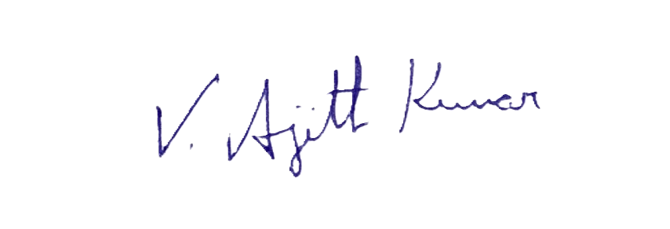For Shine Craft Technologies.,

(Ajith Kumar V)
Founder and COO

For YMC

